**Ex No: KVM AS A VIRUTUAL MACHINE**

**Date:**

**Aim:**

To run OS on top of KVM (Kernel-based Virtual Machine) virtual Machine Manager

**Procedure:**

1. KVM can only runs on Linux OS. If you don’t have Linux OS install VMs like VMWhare and install Linux on top VMWhare
2. Once that is done, we have to install KVM by following the bellow code(We have to be root user for perfoming following actions)
3. Searching Package in Repository – apt -cache search qemu-kvm
4. Installing Package from Repository - apt -get install qemu-kvm
5. Opening libvrtd.conf file to change configurations by typing nano /etc/libvirt/libvirtd.conf
6. Once it is opened in nano text editor
7. Replace with the following code

listen_addr = "0.0.0.0"

unix_sock_group = "libvirt"

unix_sock_ro_perms = "0777"

unix_sock_rw_perms = "0777"

unix_sock_dir = "/var/run/libvirt"

auth_unix_ro = "none"

auth_unix_rw = "none"

1. Virsh list - Displays no of Virtual machine running
2. Importing existing VM
3. Selecting OS to import into VM

**ScreenShots:**

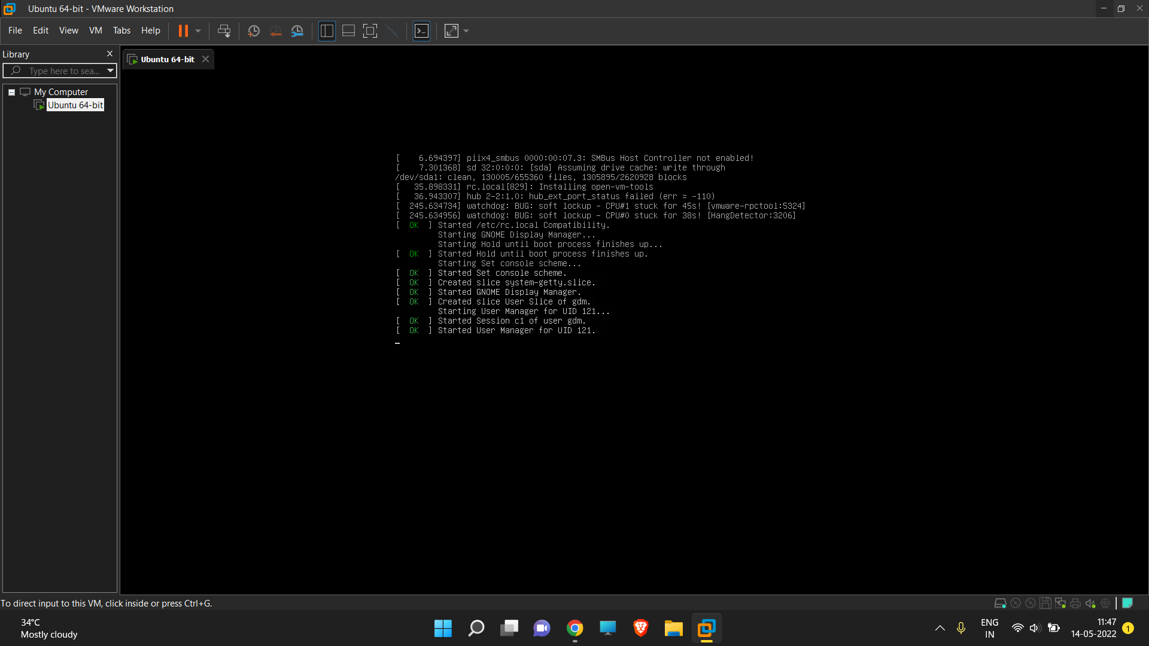

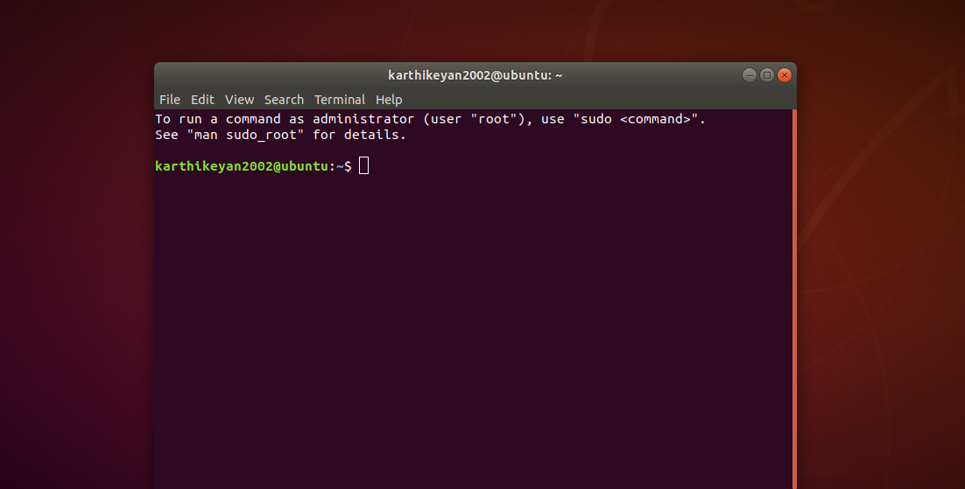

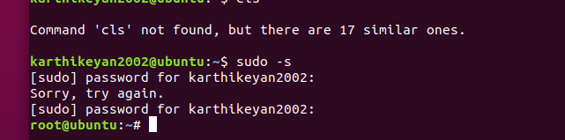

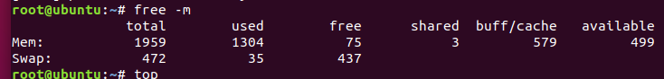

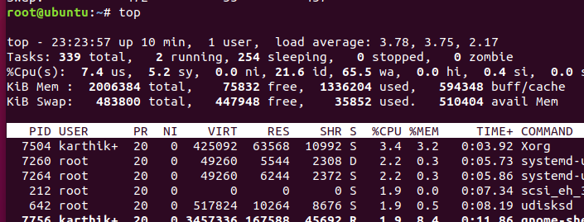

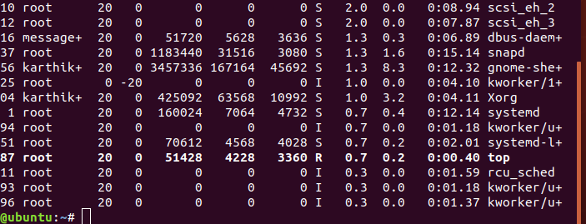

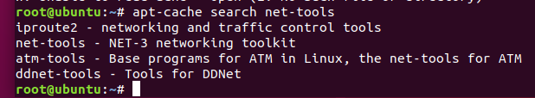

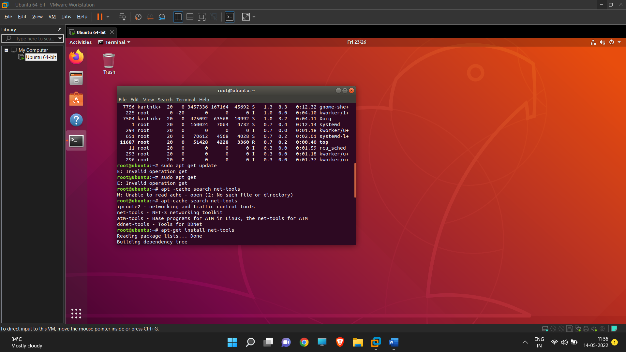

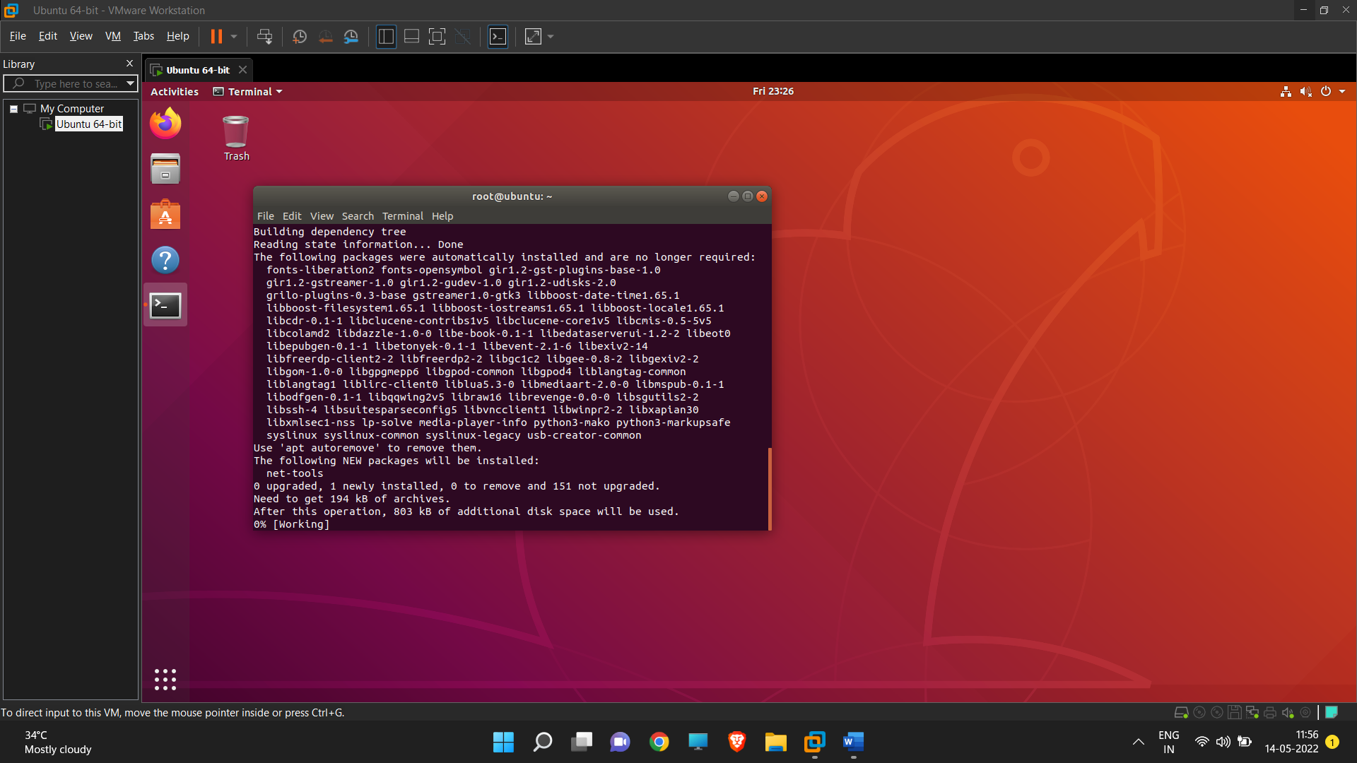

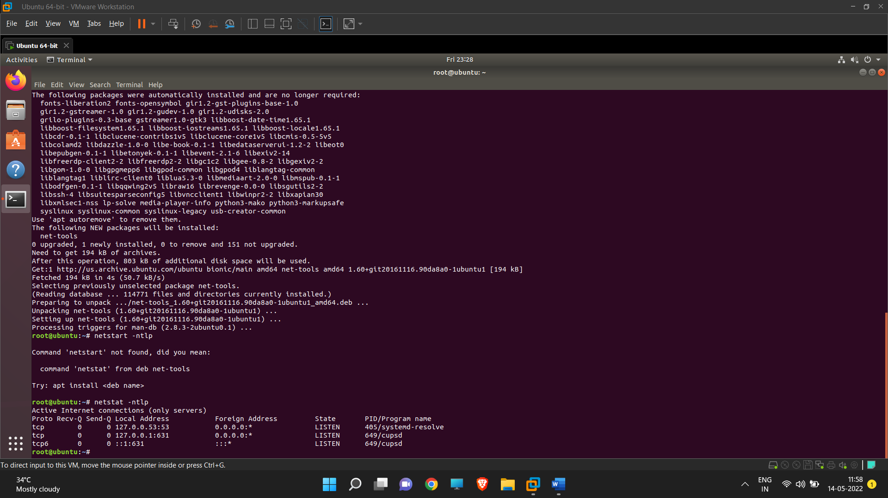

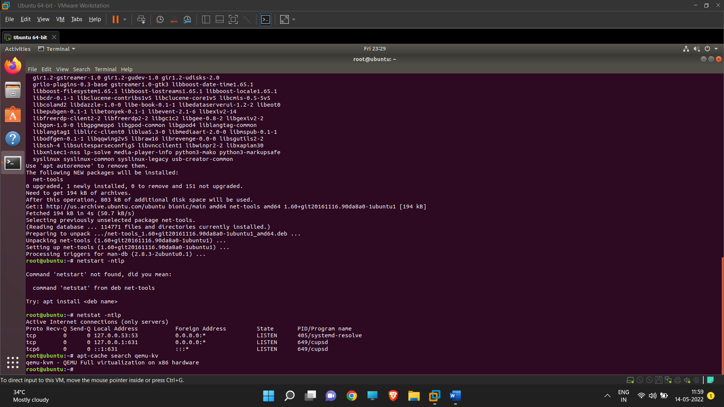

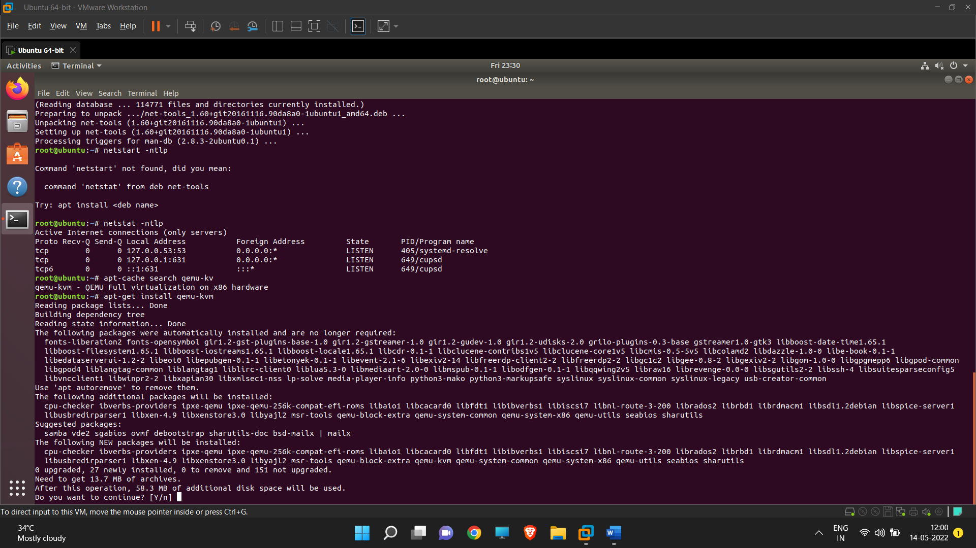

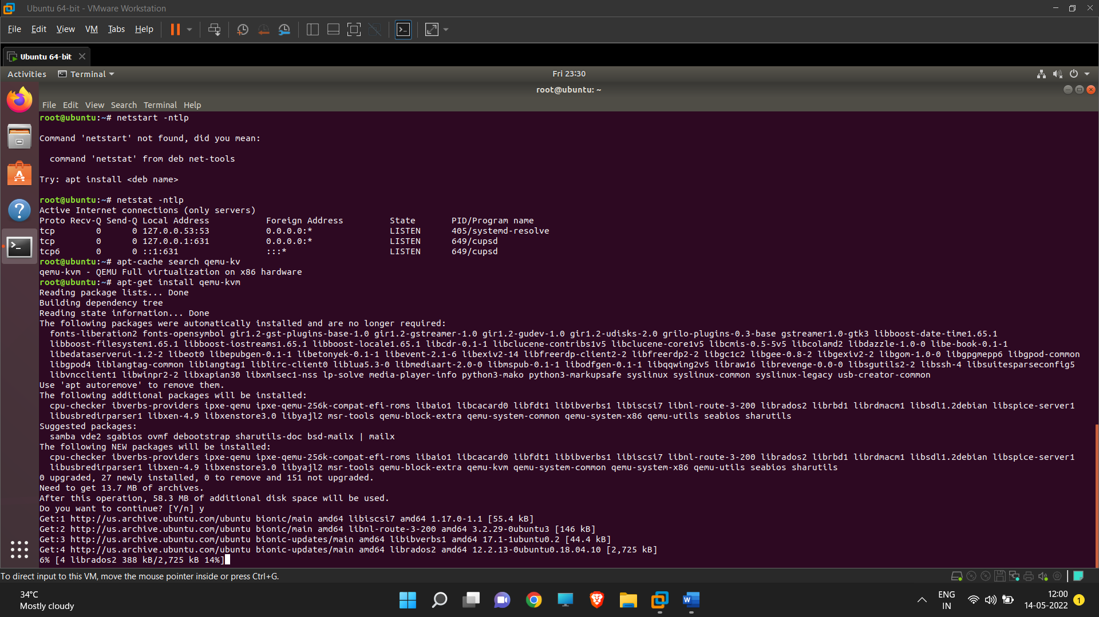

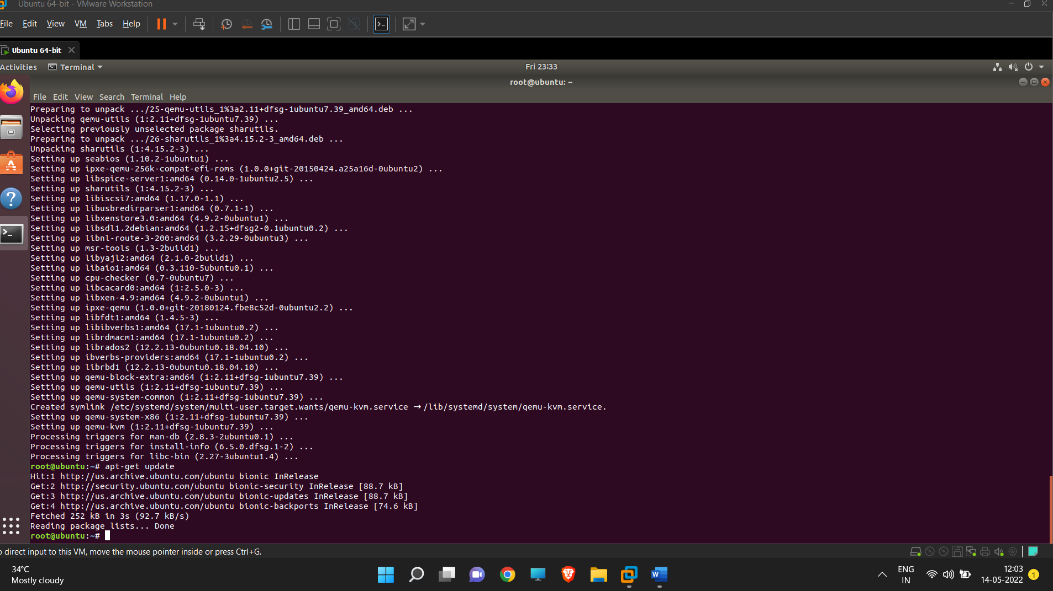

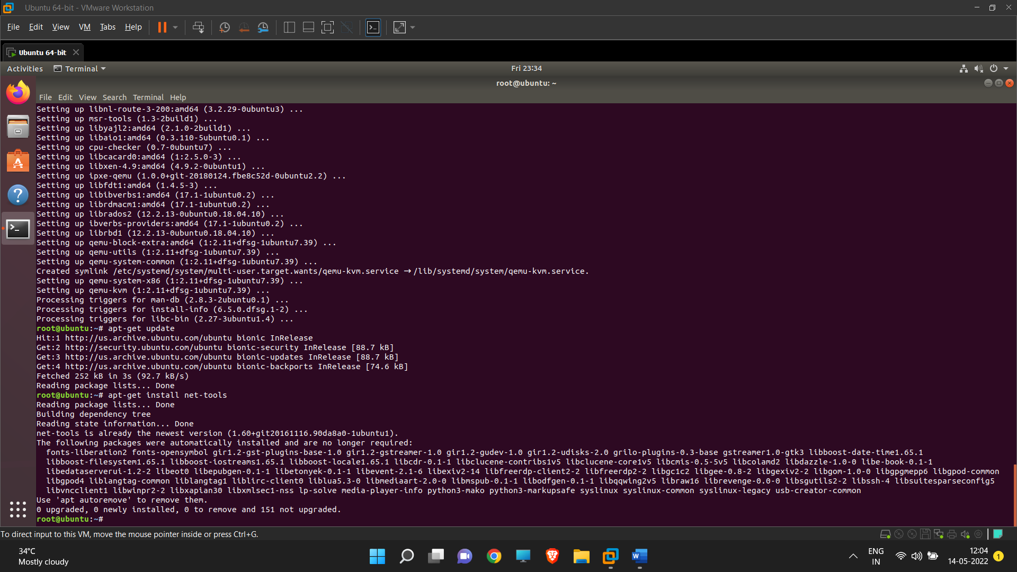

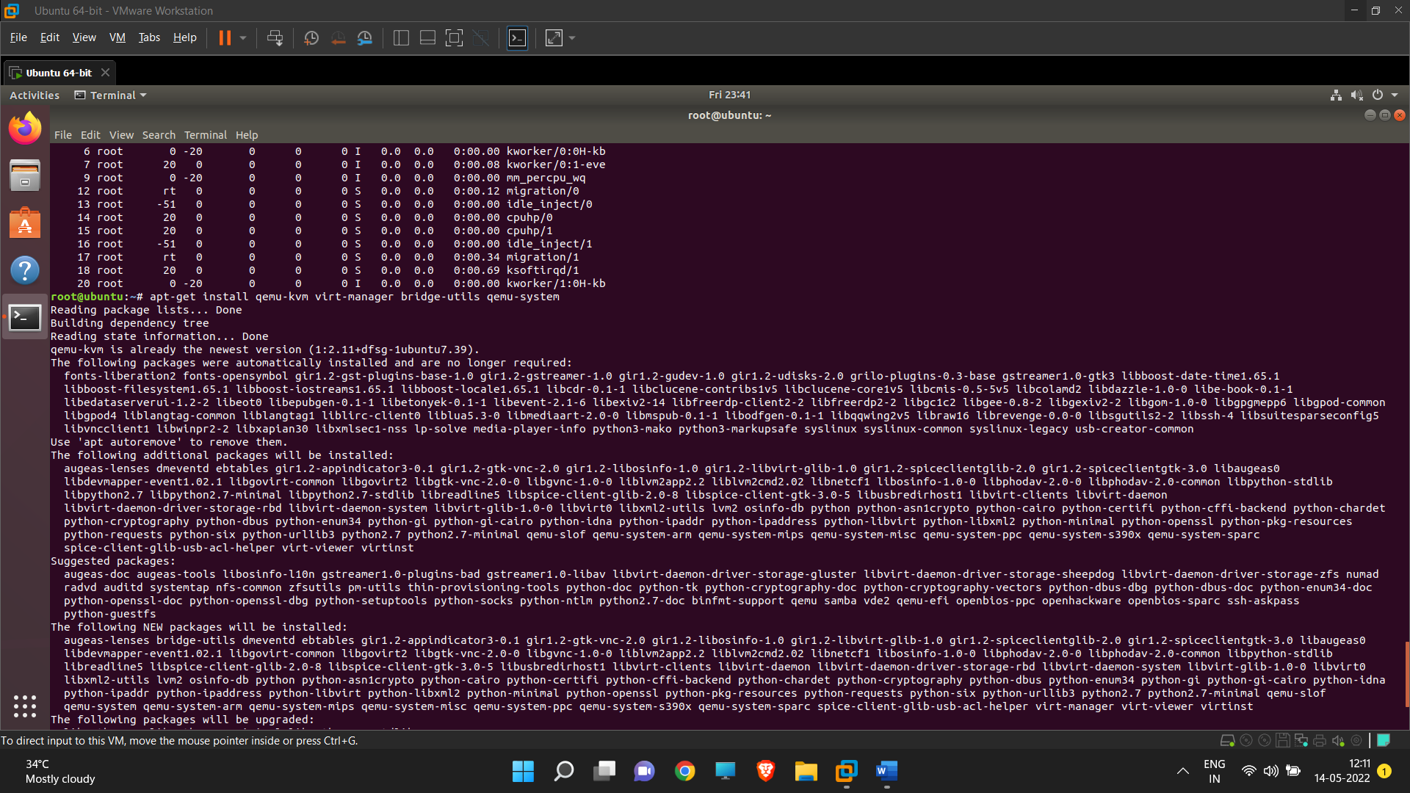

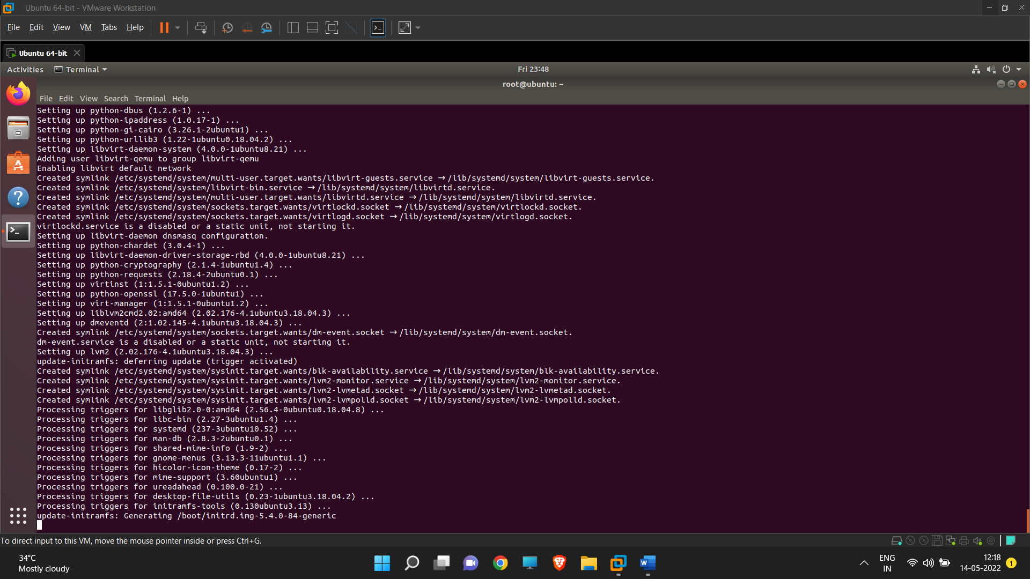

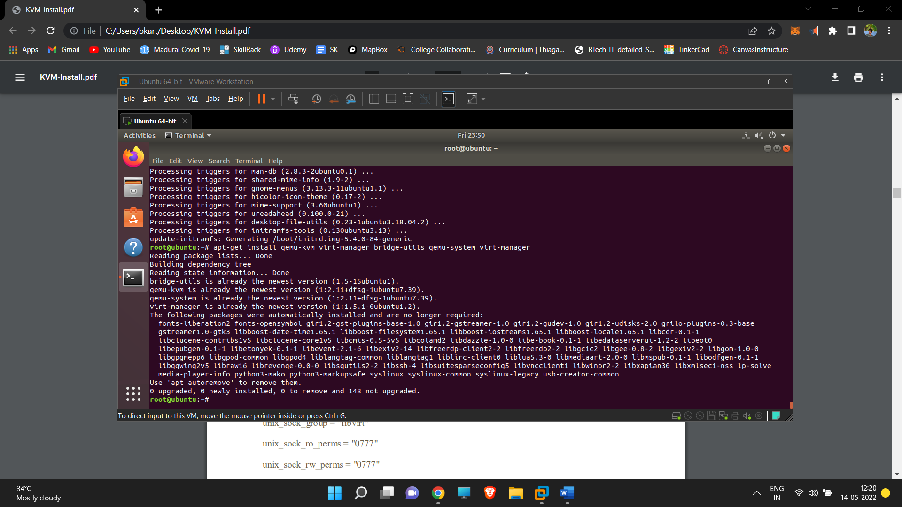

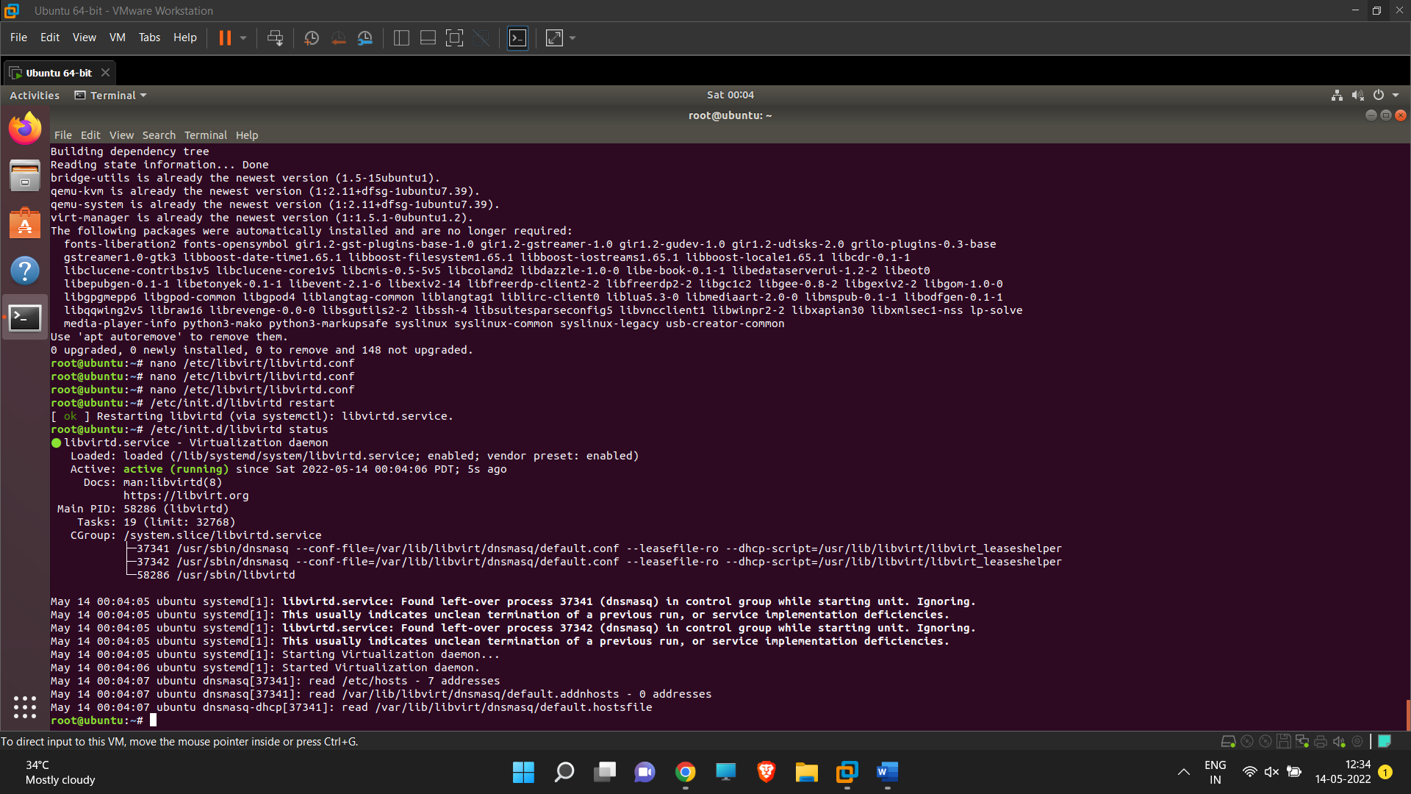

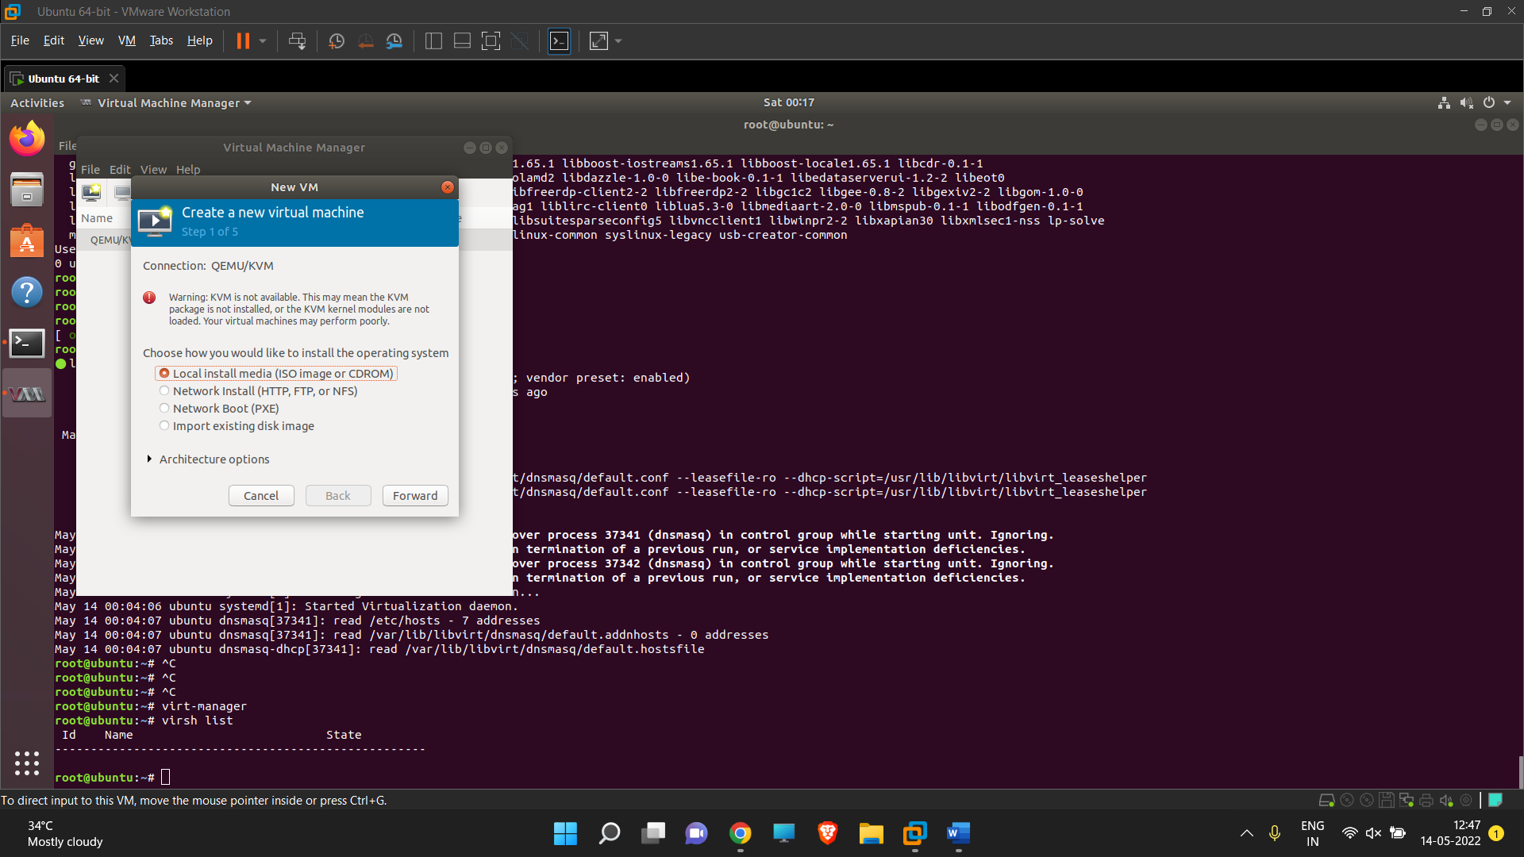 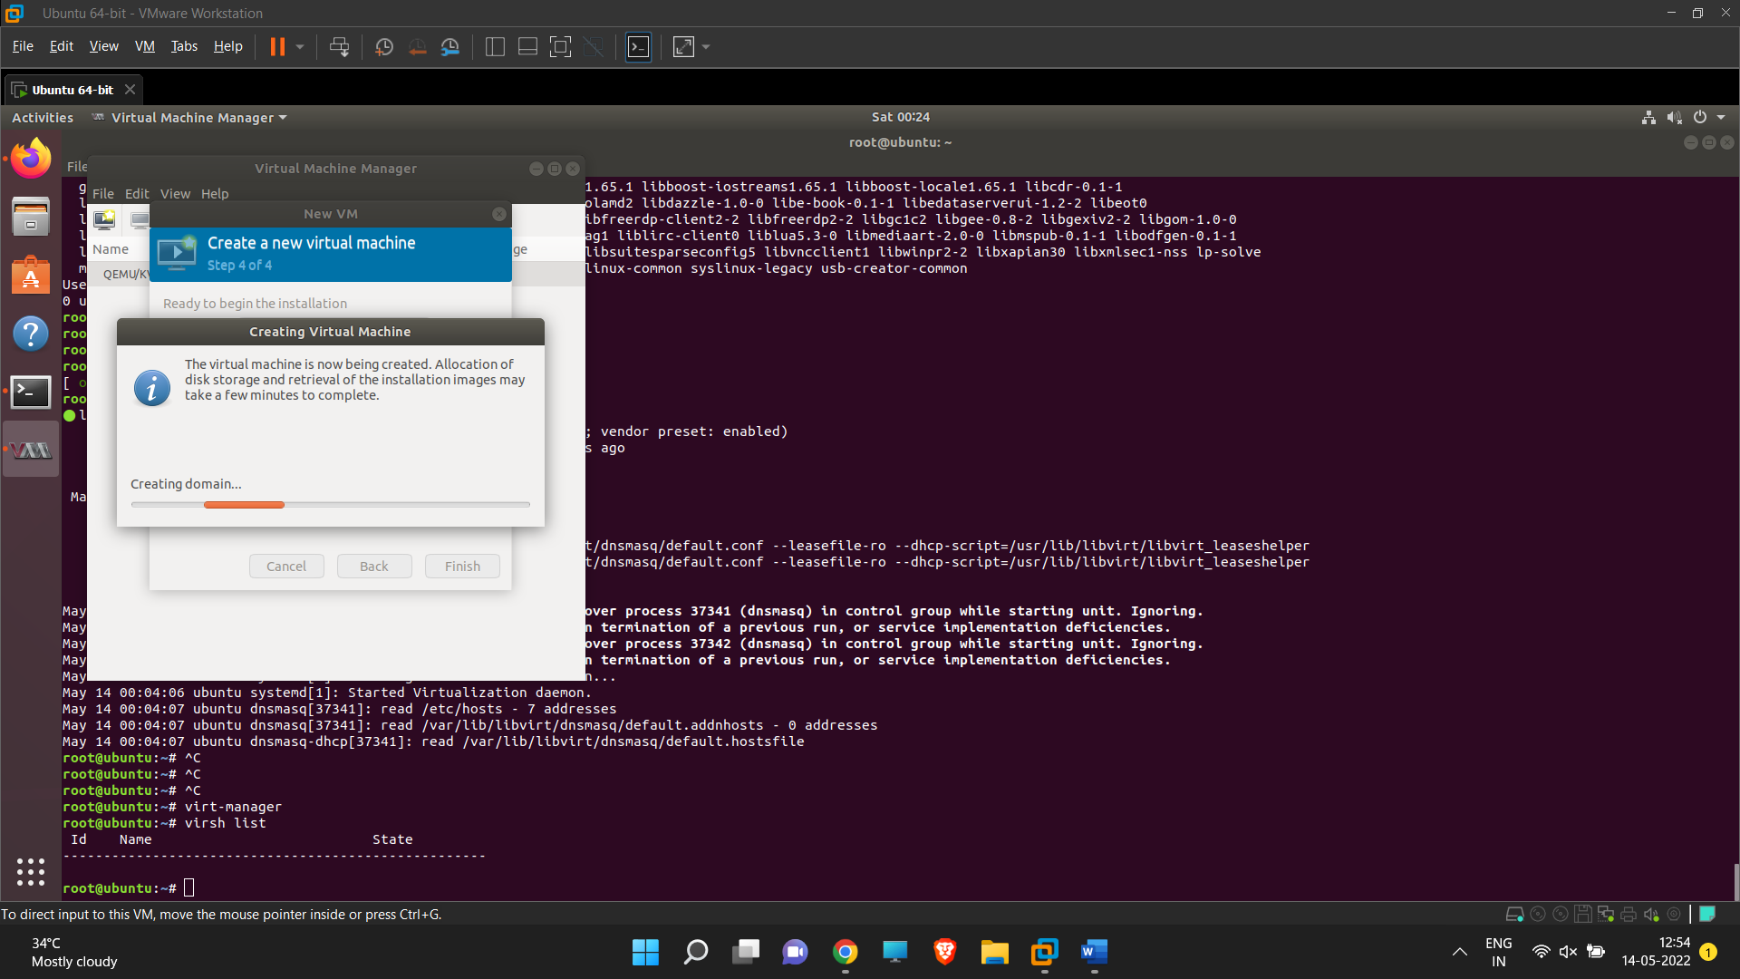

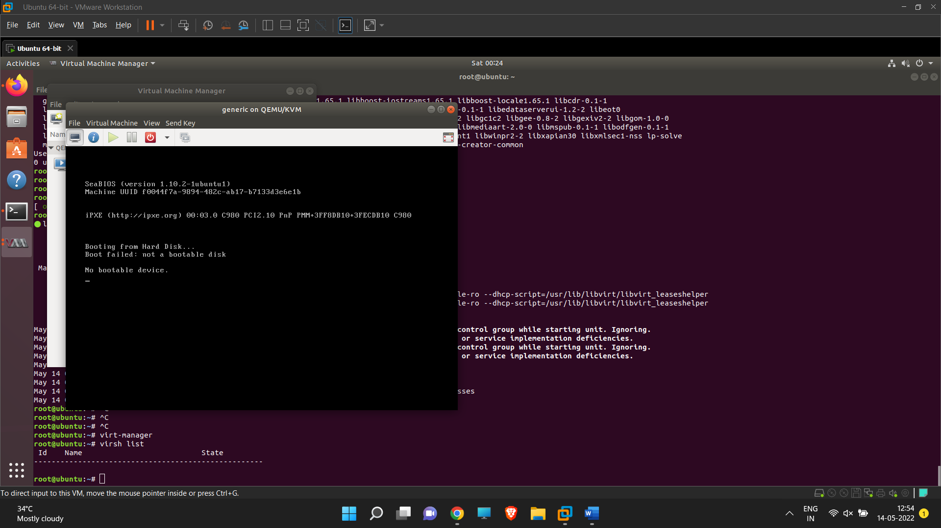 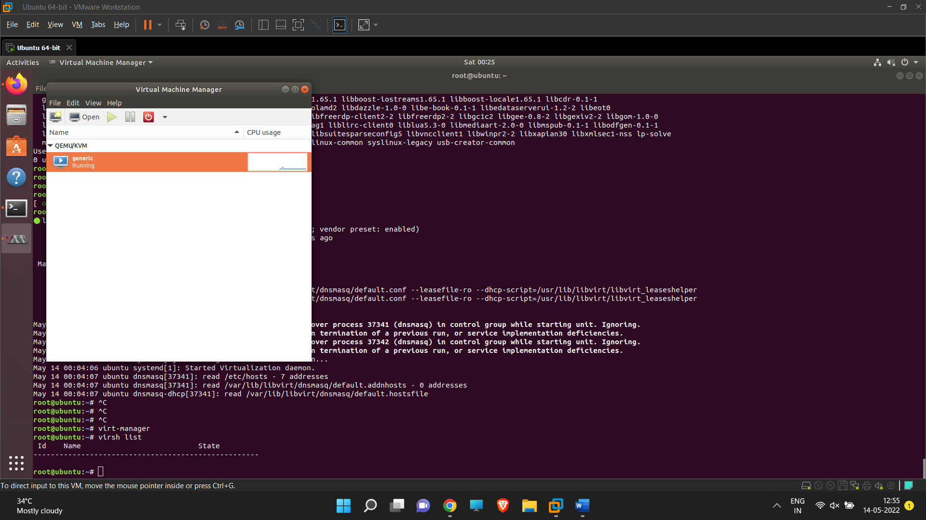

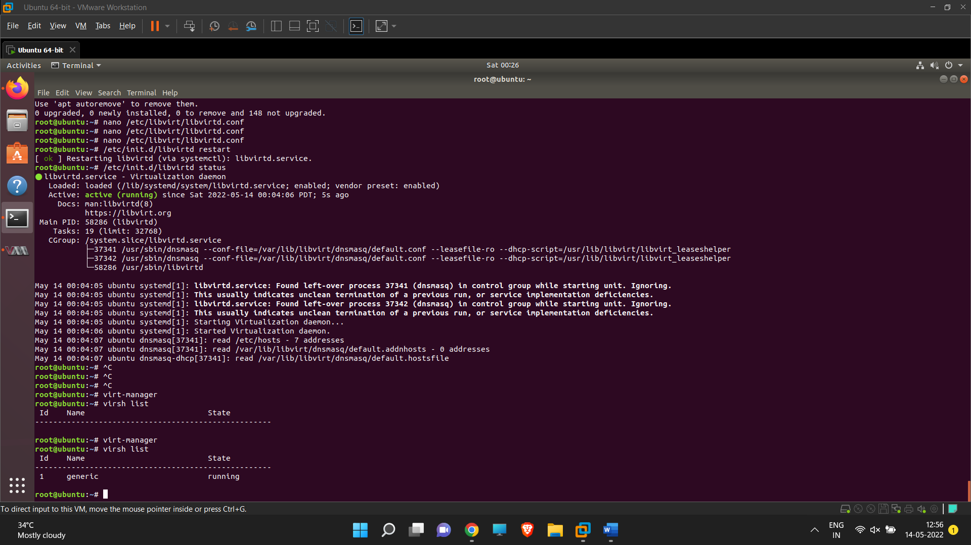

**Result:**

Thus, KVM is installed and OS on top them